Chapter One: Introduction

Background
Job portal is a web based site that brings together diverse source of employment information so as individual seeking job can apply for one.
Automated interview is an online research method conducted using computer-mediated communication (CMC) such as instant messaging, email, or video. Online interviews are separated into synchronous online interviews, for example via online chat which happen in real time online and asynchronous online interviews, for example via email conducted in non-real time.
Online interviews, like offline interviews, typically ask respondents to explain what they think or how they feel about an aspect of their social world. Interviews are especially useful for understanding the meanings participants assign to their activities; their perspectives, motives, and experiences. Interviews are also useful for eliciting the language used by group members, gathering information about processes that cannot be observed, or inquiring about the past. Thus the objectives researchers have do not differ significantly, however the methods and research design can be effected by the online component of the research which this article will take issue with.
Recently in Tanzania there have been application of job portal technology but most systems have not integrated the interviewing process in this system. It is because our interviewers still use the face to face method of interviewing individuals. Face to face interview is common in Tanzania as most people have not yet been exposed to the internet or do not have technology required to access effectively this growing community of the internet.
With this system developed the process cost of the interview process will have decreased exponentially and individual shall be exposed to the online community so as to ease their entire life.

Problem Statement
With manual methods of searching for a job and interviewing an individual our community is faced with inefficient ways of recruiting individuals with variety of needed skills and yet maintain equality through the whole process. Such inefficiency include too much cost on performing interviews, physically disabled people are an able to attend interviews and job posts information is unable to reach required person at a right time.

Project Objective

General Objective
The Objective of this project is to design and develop job search portal integrated with automated interview system that will allow individual who search for a job with required specification to perform a preset interview by an employee

Specific Objective
The following are specific objective of the project.
- To capture and analyze system requirement.
- To design and implement interviewing module/unit.
- To design and implement a module that will allow to post and view jobs.
- To integrate and perform unit testing of all system modules.

Significance of the project
- Employers will be able to post their job requirement.
- Employers will be able to target a specific people in the community.
- Carry out interviews with a very geographically dispersed population.
- Carry out interviews in a personal, yet neutral, location such as a home.
- Provide savings in costs to the researcher (for example, costs associated with travel and venue hire).
- Record data quickly and accurately.
- Reduce the environmental impact of research by eliminating the resource expenditure associated with traveling long distances.

Project Scope
The system to be developed will focus on developing a web based system with modules that will allow posting and viewing jobs, interviewing an individual and alerting an individual via email.

CHAPTER TWO: LITERATURE REVIEW

Scheduling job applicants for their interviews is a crucial component of the hiring process. Whether done by a company’s in house human resources department, through an outsourced service
or recruiting company, or assigned to hiring coordinators, the task of scheduling and managing
interview dates and times—as well as candidate information—can be tedious and
time‐consuming, especially if these interviews are scheduled over the phone, in‐person.
And based on recent survey results from the National Association for Business Economics that
projects payrolls will rise an average of 170,000 employees per month in 2012, the need for efficient
interview‐scheduling methods will become increasingly vital as the economy continues to improve.

The benefits of automated interview system include:
- Time savings, as HR personnel and recruiters spend less time on the phone scheduling, canceling and rescheduling candidate interviews. There are also fewer voice messages left by candidates that have to be returned. On average, a reduction of 70 to 80 percent of a recruiter or interview coordinator’s time scheduling interviews can be seen.
- Monetary savings, as staff responsibilities can be shifted to more pressing tasks and no
new administrative or support hires are necessary to manage the interview process. For example, a telecommunications company that schedules 500 interviews monthly saves over $3,000 in costs related to the scheduling process.
- Dramatic reduction in errors, such as overbookings, incorrect interview dates and times, and
Inaccurate candidate information.
- Greater flexibility and convenience for job candidates, as they’re able to book their interviews 24 hours a day.

What is Automated Interview System?
Online interview system differs from more traditional software programs in that it’s accessible
and securely housed completely online, making it accessible from any
Internet‐connected device. It’s not confined to an individual desktop computer or network.
Features
- Online self-scheduling, where job candidate can schedule their own interview at their home computers, laptop, smartphone, tablets or any other internet connected device.
- Automated e-mail reminders
- Advanced record-keeping and reporting capacities.
Which allow HR personnel and recruiters to instantly view interview and candidate
information from one centralized location, instead of having to search paper appointment books, spreadsheets, files or other documents that previously stored such information.
Advanced Functionality
Businesses and organizations that routinely schedule a large number of job interviews or have
specific scheduling needs can benefit from online interview scheduling software, as the
framework behind the technology easily allows for this.
Depending on the service provider selected, this advanced functionality can include:
- High scalability, which allows the software to accommodate large number of interview
appointments and candidates, staff interviewers, and different positions that the company or organization is hiring for.
- Readily available, 24‐hour live customer support from locally‐based representatives.
- Customer graphic user interface (GUI) development.

Implementation
Being a cloudbased technology, interview scheduling software does not require any downloads,
installations or additional hardware to utilize. Additionally, it typically does not require the
involvement of inhouse or contracted IT staff (unless special customization or integration is part of the implementation). Once a provider is selected, the company or recruiter usually has the
ability to configure the system to its specific needs and adjust settings to match their current
processes, such as marking available days and time to schedule interviews, adding staff
interviewers and specific positions, and specifying the type and frequency of reminders to job
candidates.

CHAPTER THREE: METHODOLODY

Introduction
Methodology is the systematic, theoretical analysis of the methods applied to the field of study, or the theoretical analysis of the body of methods and principles associated with a branch of knowledge. It typically encompasses concepts such as paradigm, theoretical model, phases and quantitative and qualitative techniques

Literature Review
For Successful completion of this project literature review on several subjects is required as pointed out below for this project
- Object Oriented (OO) System Design with UML
The main feature of object-oriented programming (like C++, Java, PHP) is that its main emphasis is on data rather than functions or procedures.
UML is a language for: Specifying, Visualizing, Constructing, Documenting and communicating the artefacts of a software intensive system. The UML is a standard way to specify, construct, and document system development that use object-oriented approach. UML is a graphical language for capturing the artifacts of software development. UML is the de-facto standard for Object Oriented modelling.
- Database Design and Implementation with MYSQL, to store all useful data
MySQL is a database management system.
A database is a structured collection of data. It may be anything from a simple shopping list to a picture gallery or the vast amounts of information in a corporate network. To add, access, and process data stored in a computer database, you need a database management system such as MySQL Server. Since computers are very good at handling large amounts of data, database management systems play a central role in computing, as standalone utilities, or as parts of other applications.

MySQL databases are relational.
A relational database stores data in separate tables rather than putting all the data in one big storeroom. The database structures are organized into physical files optimized for speed. The logical model, with objects such as databases, tables, views, rows, and columns, offers a flexible programming environment. You set up rules governing the relationships between different data fields, such as one-to-one, one-to-many, unique, required or optional, and “pointers” between different tables. The database enforces these rules, so that with a well-designed database, your application never sees inconsistent, duplicate, orphan, out-of-date, or missing data.
- Backend system development with PHP using Code Igniter Framework
Code Igniter is a toolkit for people who build web applications using PHP. Its goal is to enable you to develop projects much faster than you could if you were writing code from scratch, by providing a rich set of libraries for commonly needed tasks, as well as a simple interface and logical structure to access these libraries. Code Igniter lets you creatively focus on your project by minimizing the amount of code needed for a given task.
Code Igniter is based on the Model-View-Controller development pattern. MVC is a software approach that separates application logic from presentation. In practice, it permits your web pages to contain minimal scripting since the presentation is separate from the PHP scripting.

MVC Model
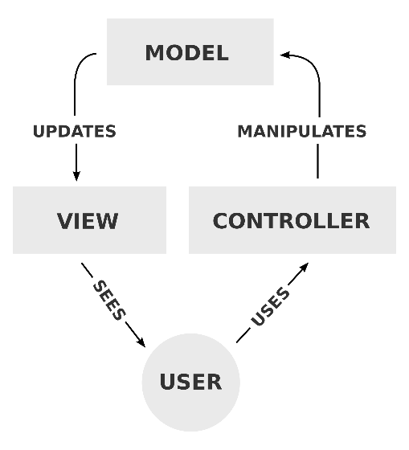
fig 3. 1
The Model represents your data structures. Typically your model classes will contain functions that help you retrieve, insert, and update information in your database.
The View is the information that is being presented to a user. A View will normally be a web page, but in Code Igniter, a view can also be a page fragment like a header or footer. It can also be an RSS page, or any other type of “page”.
The Controller serves as an intermediary between the Model, the View, and any other resources needed to process the HTTP request and generate a web page.
- Front end system development with Java script using JQuery Framework
jQuery is a fast, small, and feature-rich JavaScript library. It makes things like HTML document traversal and manipulation, event handling, animation, and Ajax much simpler with an easy-to-use API that works across a multitude of browsers. With a combination of versatility and extensibility, jQuery has changed the way that millions of people write JavaScript.

Design Approach
This project will use Waterfall software development model. The Waterfall model provides a framework for planning top – down systems development .The development flows down a number of successive activity stages the stages in the waterfall model overlap and feed information to each other .During design, problems with requirements are identified; during coding, design problems are found and so on. The development process is not a simple linear model but involves a sequence of iterations of the development activities.
Waterfall Model
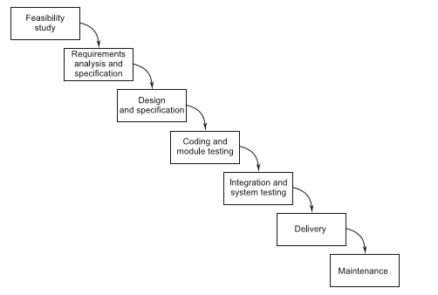
fig 3. 2

With waterfall model the following are the task that are going to be done for successful completion of the project:-

Feasibility Study. The first phase is the feasibility study. The purpose of this phase is to produce a feasibility study document that evaluates the costs and benefits of the proposed application. To do so, it is first necessary to analyze the problem, at least at a global level. Obviously, the more we understand the problem, the better we can identify alternative solutions, their costs, and their potential benefits to the user.
Requirement Analysis and Specification. This phase exactly tells the requirements and needs of the project. This is a very important and critical phase in the waterfall model. The requirements describe the “what” of a system, not the “how.” This phase produces a large document and contains a description of what the system will do without describing how it will be done. The resultant document is known as the software requirement specification (SRS) document.
Design and Specification. The goal of the design phase is to transform the requirements specified in the SRS document into a structure that is suitable for implementation in some programming language. In technical terms, during the design phase the software architecture is derived from the SRS document.
Coding and Module Testing. Coding and module testing is the phase in which we actually write programs using a programming language. The output of this phase is an implemented and tested collection of modules. Module testing is also often subject to company standards, including a precise definition of a test plan, the definition of testing criteria to be followed (e.g., black-box versus white-box, or a mixture of the two), the definition of completion criteria (when to stop testing), and the management of test cases. Debugging is a related activity performed in this phase. Module testing is the main quality-control activity that is carried out in this phase. Other such activities may include code inspections to check adherence to coding standards and, more generally, to check for a disciplined programming style, as well as checking of software qualities other than functional correctness (e.g., performance), although this is often better done at a later stage of coding.
Integration and System Testing. During the integration and system testing phase, the modules are integrated in a planned manner. The different modules making up a software product are almost never integrated in one shot. Integration is normally carried out incrementally over a number of steps. During each integration step, the partially integrated system is tested and a set of previously planned modules are added to it. Finally, when all the modules have been successfully integrated and tested, system testing is carried out. The objective of system testing is to determine whether the software system performs per the requirements mentioned in the SRS document. This testing is known as system testing. A fully developed software product is system tested.

Advantages of Waterfall Model
- The various advantages of the waterfall model include:
- It is a linear model.
- It is a segmental model.
- It is systematic and sequential.
- It is a simple one.
- It has proper documentation.

Data collection

Primary data
Is data collected or observed from directly from first-hand experience. This project shall use open ended interview system so as to gather system requirement and user requirement for the system.
Secondary data
Is the data published and collected in the past or other parties. This project shall use the following source for secondary data collection.
Books
Newspapers
Internet

